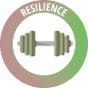
Lesson 3: Self Talk
Watching the clip, what is the difference bet ween these 2 men?
I'm rubbish at football, I bet I don’t even get the ball
I’ll have no one to sit next to if I join the new club

How would these thoughts make you would these thoughts make you feel? Draw an emoji and / or lable an emotion.
I’m not popular enough to be head girl/boy
I hate writing, I'm really thick
Climbing the wall is too scary, I’ll cry
It’s no wonder Sarah doesn’t like me, I'm ugly

I’ll have no one to sit next to if I join the new club

I'm rubbish at football, I bet I don’t even get the ball

What do all these emotions have in common?

Now do the same with these thoughts / self talk.
I’d really like to be head/girl or boy, I’m going to apply and see what the teachers say
If I practice my writing, I’m sure I’ll make some improvement

The climbing wall is huge, but if I take it one step at a time what an achievement it will be

If I join the new club I wonder who I’ll meet

Football isn’t my strongest sport but I’ve heard that the coach is really great
I’d like to get to know Sarah, I’m sure we’ll find things in common.

What do all these emotions have in common?
Positive Self-Talk | Situation | Negative Self-Talk
 | Having to stand up in front of the class
 | Going for an audition for a play
 | Having coursework to finish by the end of the weekend
 | Asking someone out you fancy
 | Failing out with a friend
 | Getting poor results on a maths test
 | Taking an exam in a subject that you don’t enjoy
 | Being told you can’t stay out late
 | Wanting to wear clothes that other people may not find cool

Task 1: List your key strengths | Task 2: Make these into positive, self-talk sentences
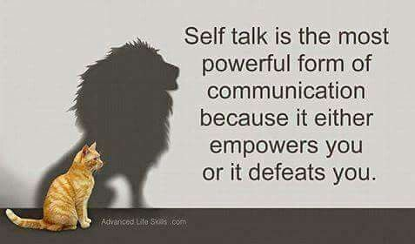
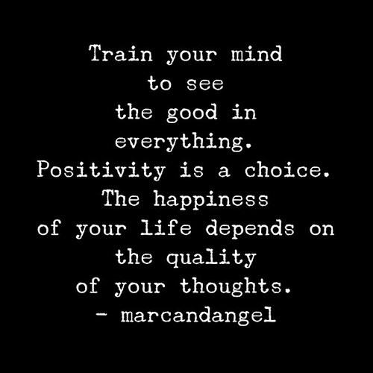
- ID Competition Planning

