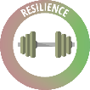**Introduction to Resilience**

What does resilience mean?

|  |
| --- |
| Initial thoughts: |
| Dictionary definition: |
| Extra detail from the research: |

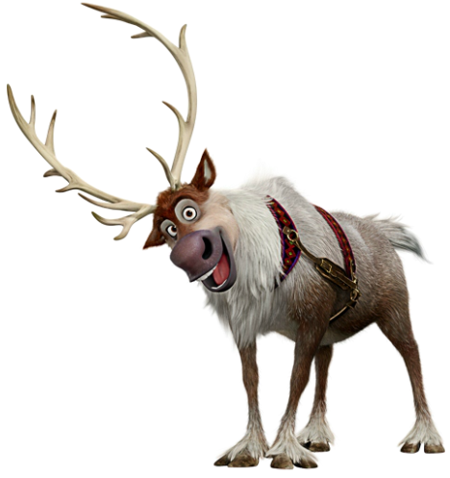

|  |
| --- |
| How does this clip show resilience? |
| Extension: what is the message of the clip? |

|  |
| --- |
| In your pairs, think of 5 situations where you may feel unsure, scared or feel defeated:  1)  2)  3)  4)  5) |

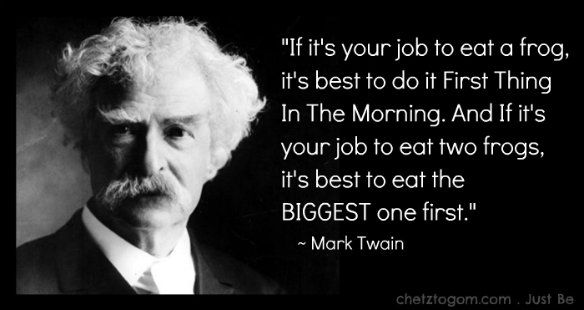

|  |
| --- |
| What does this quote mean? |

|  |
| --- |
| Native American Genealogy Research | Lineages GenealogyWhat does this story tell us about how we become resilient? |

**The Two Wolves**

An old Cherokee was teaching his grandchildren about life. He said, “A battle is raging inside me…it is a terrible fight between two wolves. One wolf represents fear, anger, envy, sorrow, regret, greed, arrogance, self-pity, guilt, resentment, inferiority, lies, false pride, superiority and ego. The other stands for joy, peace, love, hope, sharing, serenity, humility, kindness, benevolence, friendship, empathy, generosity, truth, compassion and faith.”

The old man looked at the children with a firm stare. “This same fight is going on inside you, and inside every other person, too.”

They thought about it for a minute, and then one child asked his grandfather, “Which wolf will win?”

The old Cherokee replied: “**The one you feed**.”

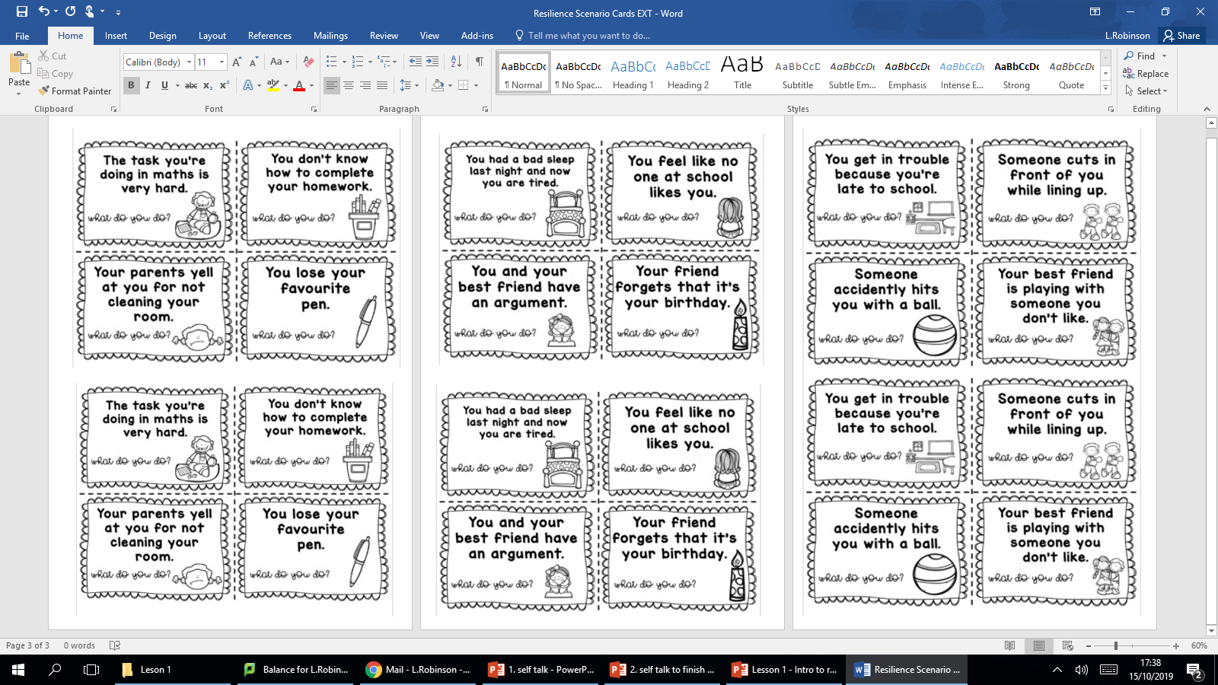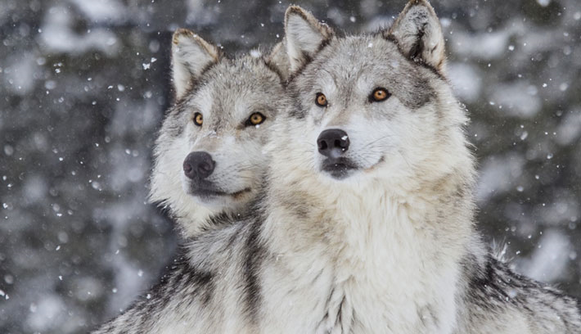

**How can we show resilience?**

How would you initially react to these situations? How would a resilient person react to these situations?

