JBS Student Reflection Form
Name: Date:
Grade:

Why were you asked to fill in this reflection form today? What happened?

What were your thoughts and feelings before, during, and after the above-described situation?

What different choices would you make if you were in this situation again?

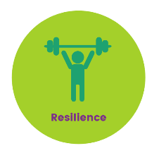
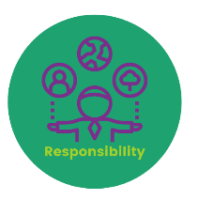

Character in Action
In the boxes below, please use the 4 R’s to reflect on the above-described situation.
How could using the 4R’s help you make better decisions?

Responsibility  I am accountable for my actions and stand up for what is right. | Respect  I treat myself, others and the environment well.
Resilience  I do not give up in challenging situations and also help others to do well. | Resourcefulness  I find innovative solutions for positive outcomes.

