 | Thursday | Friday | Monday | Tuesday | Wednesday | Thursday | Friday
Focus Virtue | Kindness  K is for Kindness - Bing video | Perseverance  Treasure Champs - What is Perseverance? | Cartoons for Kids | Wizz Friends - YouTube | Honesty  The Honesty Song - YouTube | Respect  Kids For Character: Respect - YouTube | Respect  Respect Song | With Action | Classroom Song | Assembly Song| School Song - YouTube | Responsibility  https://youtu.be/3HOKo8H7dLg | Responsibility  Let's Be Responsible Song - YouTube
Lesson 1 | K is for kindness story powerpoint.  Children to design their own kindness badge and write a sentence about who they would award their badge to and why.  Sesame Street ELMO Spaceship Kindness-1 - Bing video  Read stick and stone - Stick and Stone by Beth Ferry (Read Aloud) | Storytime | Friendship - YouTube | The little engine that could - "Goodnight with Dolly" | Episode 1 | Dolly Parton reads "The Little Engine That Could" - YouTube  Children to have a train – On the train write I think I can and then on carriages write down 5 things they want to persevere with in Year1.  Read whistle for willie powerpoint – discuss how this story is similar to the first. | Ruthie and the not so teeny tiny lie powerpoint.  Children to write a letter to Ruthie telling her what to do next time. | Do unto otters. https://youtu.be/-ZhcdyJ_Oq4  Children to write a poem where every line starts  I would like otters to …  Complete a respect and disrespect sorting activity. | The Crayon Box That Talked - Read Aloud by Mr. Joshua Brooks - YouTube  - Children to have one of each colour to create a picture showing each colour respect.  - Children to: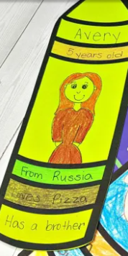 | I’ll do it. I'LL DO IT, TAKING RESPONSIBILITY (BOOK)KIDS READING WITH ENGLISH SUBTITLES - YouTube ( muted and read over)  Children to then write sentences and draw pictures about what they are responsible for. 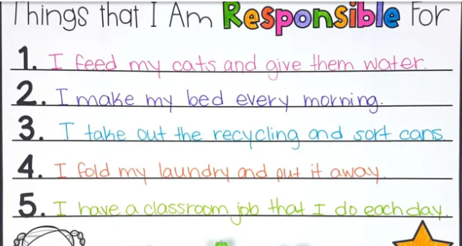 | Even superheroes make mistakes. Story Time: Even Superheroes Make Mistakes - YouTube  Children to understand that it is ok to make mistakes but we should take responsibility for our actions and by taking responsibility of our actions we are in charge of our own journey.  Children to create their own superhero masks. Children to make a responsibility pledge – what do they want to be responsible for?
Lesson 2 | Read the kindness quilt powerpoint.  Circle time – things they do that are kind. Children to all have a different idea. Children to collage. Put all together as a quilt.  Read plant a kiss. Plant a Kiss by Amy Krouse Rosenthal, read aloud - ReadingLibraryBooks - YouTube  Watch sidewalk flowers.  Sidewalk Flowers - Visuals set to Music - YouTube | The most magnificent thing. The Most Magnificent Thing (Read Aloud) | Storytime Ashley Spires - YouTube  Children to draw a design for a magnificent invention.  Watch Perseverance - a 2D Animated Short Film - YouTube  Children to write the story for the film. | Elis lie ometer "Eli's Lie O Meter" - YouTube  (might want to play on mute and then read over)  Children make a truth ticket. | the best me that i can be respect powerpoint.  Have 10 boxes on the page.  In the top boxes draw a person they show respect to.  In the bottom box write a sentence to say how. | The lumberjack’s beard  The Lumbjack's Beard ~ Read Along With Me Simple Story Time - YouTube  Children to draw the animals in their homes. Draw the lumberjack and write a speech bubble about what he has learnt about respecting the environment. | The little red hen.  The Little Red Hen #ReadAlong StoryBook Video For Kids Ages 2-7 - YouTube  Children to talk about who took responsibility in the story and did they deserve to eat it at the end.  Sequencing cards to show the story events. | The red bike Mrs. Primm reads The Red Bicycle - YouTube  Set up a donation stand outside of Year 1. Things that fit in a shoe box. We will then send them off to those who need.  Children to create a flyer to send home with them explaining what they are trying to achieve.
PM Story | Kind by Alison Green. KIND READ ALOUD! - YouTube  Teachers to take photos of children being kind in CP to display.  Create a class kindness jar.  CP – kindness colouring  Have sidewalk flowers pictures for children to write about. | The power of yet by maryann The Power of Yet by Maryann Cocca-Leffler - YouTube  The Magical Yet. - YouTube  CP stations each to have a challenge – Egg and spoon races, ring toss, beanbag in a bucket, ping pong tables, cup stacking, | Princess K.I.M and the lie that grew - YouTube  Children could make honesty crowns. | Read interrupting chicken. Interrupting Chicken AR Read aloud- accelerated reader channel - YouTube  Respect art.  Lots of group work activities | Read I am a cat. I Am A Cat By Galia Bernstein | Children’s Book | Read Aloud - YouTube  Talk about different types of cats. Look at pictures of cats.  Are any of the cats more cat than the other types of cat or are they all unquic in their own way? Should they treat each other differently or with respect?  Make cat masks.  Books about cats.  Paint cats.  Build houses for different types of cats. | Stanley and the class pet. Week Four: Stanley and the Class Pet - YouTube  William and the guinea pig. William And The Guinea Pig - YouTube  Look at the responsibility of looking after pets.  Ask staff who have pets to bring them in.  DN – guinea pig  NL – Snake  KP – dragon  Children to draw pets and label.  Read books about animals. | Bunny money bunny money - YouTube  Talk about spending money responsibly. What does this mean?  How could Max have been more responsible?  Role play shops – link to responsible spending and thinking of others.
End of the day story | Little blue truck  🚙 Book Read Aloud: LITTLE BLUE TRUCK | Little Blue Truck Series - YouTube  Octonauts - Showing Kindness to Others | Cartoons for Kids | Underwater Sea Education - YouTube | Watch the boy and the airplane The Boy and the Airplane by Mark Pett - YouTube and the girl with the bike. The Girl and the Bicycle by Mark Pett - YouTube Compare the books and talk about how each child perseveres within the story. | Edward Fudwupper Fibbed Big - YouTube | https://youtu.be/TmRjyQlWyQg  Sing along and discuss each story. | Library lion  Library Lion by Michelle Knudsen - YouTube | Strega Nona Strega Nona - YouTube  Read and talk about the responsibilities of each character. | Subway sparrow. Subway Sparrow - YouTube  Talk about how the people knew their responsibilities and they didn’t let differences stop them from helping the bird.

The morning task should be the virtue on the board – What does this mean? Give an example. Children to put their names on the slips so you are able to see their thoughts as they will complete this at the end of the day too – hopefully we will see a difference in their responses (unless they are able to answer well already)
Ideally would be good for the first seven days if you could have a display area per virtue and show value to the work they are completing and showing how the virtues differ.

Children should apply what they know about the virtue to the end of the day story.

