Colmore Reading Curriculum
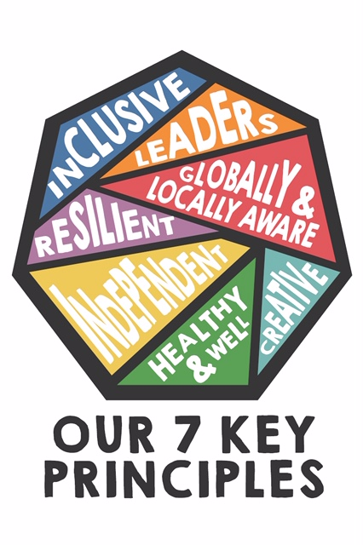
Delivery of the core principles
KEY PRINCIPLES | Lower School delivery | Upper School delivery | Progression of skills  Building on knowledge
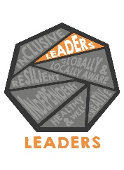 | On entry to the junior school, children are introduced to the core skills of reciprocal reading and how these are delivered in KS2. As they progress through the phase they gain confidence in the structure of these sessions and, on occasions, take the lead role in the delivery of certain aspects of reading with their peers. This can be through the use of questioning and leading discussions on the prediction of the text. | When entering the upper phase of KS2, children are more familiar with the structure of reciprocal reading so that by the time children are in Year 6 they are equipped with the leadership skills to plan, deliver and lead small group reciprocal reading sessions with Year 2 pupils. Part of this process is pupils being able to adapt the questioning to suit the needs of younger children and lead discussions effectively. | Children build on their knowledge of how texts are structured in order to successfully adapt and refine for the delivery to younger children. Skills of comprehension are extended from lower to upper school through an ability to predict, clarify, question and summarise a text in detail.  KEY READING SKILL: Reciprocal reading
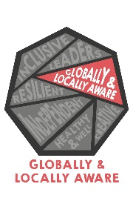 | In lower school, children explore the world around them through studying the text ‘Actual Size’. They deepen their understanding of how books are organised and used to capture the reader’s interest, whilst also providing factual information. As they move through the phase this is further developed through the story of ‘The Green Book’ where children explore what life would be like on a new planet. They use the images to develop their inference skills and understand the events unveiled in the texts. | Through work on discussion texts children take their understanding a step further by identifying the reasons for and against the building of the Three Gorges Dam on the Yangtsze River, in the text, ‘Is it a good idea?’. They look closely at the impact of the dam on the lives of ordinary people and the environmental impact that this has had. Gaining an understanding of the world around them is developed further in Year 6 when pupils read World War 1 poetry and non-fiction texts. They extend their understanding through the inferences gained from the heroism of animals in the war such as Gallipoli Murphy. | The children’s knowledge of the world around them both locally and globally is developed across the phases through the initial local understanding of environmental issues in lower school to the wider impact of major world events in Year 6. Children extend their inference skills by moving from simple pictorial inferences to more advanced inferences when studying war poetry and identifying how the men would have felt in the trenches.  KEY READING SKILL: Inference
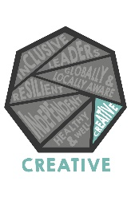 | In lower school, children explore shape poems and calligrams. They read a range of poems from these styles and identify the impact of their presentation. They make comparisons between different calligrams and explore how the words create images to help with the understanding of the text such as Gina Douthwaite’s book ‘What Shape’s an Ape’. | In Year 5, children read poems by Miraslov Holub such as ‘Go and Open the Door’ which is associated with the work of the artist Marc Chagall. They explore how the imagery in the painting is discussed within the poem and use these to understand the links with poetry and art. This approach is also used when in Year 6, children look more closely at the poem ‘Brueghel’s Winter’ by Walter de la Mare. They make direct comparisons between the images and poetry. | Children gain a greater knowledge of how creativity is developed through the reading of poetry. Initially this is through focussing on shape poems and how these present an image, to making links and comparisons between art and English in upper school.  KEY READING SKILL: Comparison
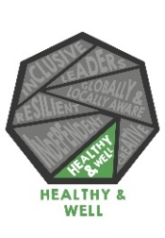 | When children first join the junior school they carry out a reading unit of work designed to support their transition from KS1 to KS2. This is achieved through reading The Dot - Peter H. Reynolds. Exploring emotions is also a theme which is developed in to Year 4 when they read stories from ‘The Fib’ by George Layton. These topics both focus on personal feelings and empathy. | In upper school, feelings and emotions are explored further by reading a range of first-hand accounts of survivors from The Titanic. Such as a biography of Eleanor Widener, a newspaper account of Jack Thayer and the Collyer family. Children discuss the well-being and mental health of the people who survived and how they felt as a result of the disaster. | Children develop their understanding of how others feel as well as their own health and mental well-being through key facts as well as through their own inferences. They relate this to a historical context too and the long term impact events can have on people’s well-being.  KEY READING SKILL: Inference
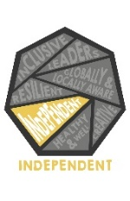 | Children across school carry out their own independent reading through a range of subjects. In Year 4, children use their own research and independent reading to support them in finding out more about Penguins as part of a unit of work on information texts. They use their skimming and scanning techniques to identify key facts to support their retrieval skills. | In upper school, children read independently for a range of purposes. One of which is when children carry out research about World War 2. They use their independent reading research to support them when asking questions of an evacuee. They develop their retrieval skills to help them to choose appropriate topics on which to question. | Children build their own knowledge of different genres and topics whilst carrying out their own independent reading. They use their retrieval skills to help them to identify key pieces of relevant information. This is then used to support children in their own personal writing.  KEY READING SKILL: Retrieval
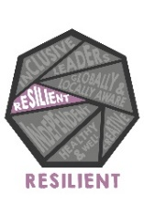 | In Year 3, children read the story Ish by Peter H Reynolds which helps them to understand the importance of resilience and how it doesn’t matter if things aren’t quite perfect. In Year 4 this is developed further through exploring a range of fables including the Frog in the Milk Pail which helps children to understand the importance of not giving up. Both texts support pupils in making predictions about how the stories could unfold depending on the attitude of the characters. | In Year 5, children read Born to Run by Michael Morpurgo. This story explores the resilience of the characters and how they deal with knock backs and difficulties in their lives. Children make predictions throughout their work on the text which helps them to gain a better understanding. Further up the school in Year 6 the children explore the resilience of soldiers and their families in World War 1 through the War poets including Wilfred Owen. | Pupils’ knowledge is broadened through the simple stories of lower school to the more complex real-life events of World War One. Throughout both phases children gain a better understanding of how to use resilience when faced with difficulties. Children are able to make predictions about how events could unfold depending on a character’s resilience.  KEY READING SKILL: Predictions
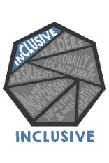 | Texts are selected in lower school which relate to a wide range of backgrounds and cultures. This is especially true during multicultural week when Year 4 explore The Windrush Story by K.M Chimbiri and Year 3 We are Britain by Bejamin Zephaniah. By reading these texts children gain a better understanding of what inclusivity means and, in so doing, read to understand more by inferring the feelings and emotions of people from different cultures. | In Year 5, stories are shared from a range of cultures including the Anansi stories, How Music Came to Earth and The Rainbow Bird. Specific features are identified and used to support the understanding of the texts including sharing texts from children’s own cultural backgrounds. In Year 6, inclusivity is developed through exploring the The Arrival by Shaun Tan. Children gain a better understanding of how it would feel to be a refugee in an unknown country using their inference skills. | Inclusivity is a common thread across a range of texts that are shared in both phases. Knowledge is gained around a range of different topics from the wider world to closer to home. Children use their inference skills to gain a better understanding of how people can feel in different, unfamiliar situations.  KEY READING SKILL: Inference

