Colmore Design & Technology Curriculum
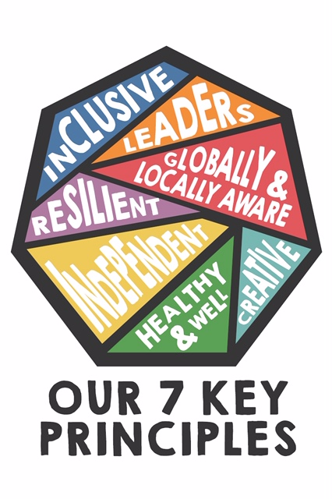
Delivery of the Core Principles
KEY PRINCIPLES | Lower School delivery | Upper School delivery | Progression of skills  Building on knowledge
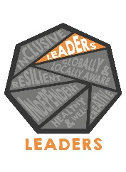 | In lower KS2 the students will present their creative ideas to the rest of the class through the design phase of their topics. This is done with each topic the students take part in. Students will be quizzed by teachers as to why they made those choices. This can be seen in the Christmas stocking topic or the Healthy choice sandwich topic. | In upper KS2 students are more familiar with presenting their work and will be able to explain their rationale behind the choices they have made. Students can also explain what went well and what changes they would make next time, verbally. This can be seen in the mechanical levers topic or the Year 5 purse topic. | Students develop their ability to talk publicly about decisions they have made and justify their choices.  Key Skills- Developing presentation skills and openly justifying choices with their peers.
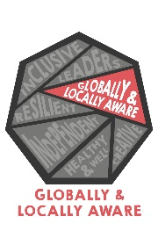 | Through the topics covered in Years 3/4 the students will be exposed to environmental issues, economic issues and technology that has shaped our world. Seasonality is also covered in the healthy food topics. Fairtrade links with the OWL lesson and also the healthy choice lessons. Technology links with the economic and environmental issues. | Seasonality is covered in greater depth in upper KS2. This is shown through Celebrating foods of the world. Students will be able to identify what foods come from where and when. Their understanding of environmental concerns will be deepened through the Culture of food topic. | Students are developing their understanding of how things can be affected by seasons and by the impact that humans have on the planet and our resources.  Key Skills – Understanding environmental concerns/changes in seasons.
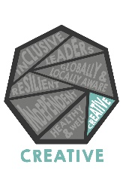 | Lower KS2 links with creativity through Christmas stockings, Sandwich making, Pop-up books and packaging topics. All of these topics have a design element and a making/constructing element. Students will initially assess current designs/products and then design their own so that it is fit for purpose. | In upper KS2 students use the topics, pasta sauces, textiles, shelters and mechanical levers to further develop their creativity. These topics deepen their understanding of the creative process of design and build. | Students deepen their ability to think creatively and take part in creative processes. This is developed across each year group.  Key Skills – Understanding design and creative choices.
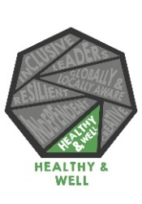 | Lower KS2 links with Healthy Choice ingredients for sandwiches and Fruit Juices. Students will explore and experiment with varying ingredients to make a healthy choice. Discussions around healthy eating and allergens will take place in classes. Students will then create a variety of sandwiches/juices that take into account healthy eating and allergens. Seasonality will also be explored in these topics. | In Year’s 5 and 6 Pasta sauces and world foods are covered. Healthy choices are a part of these topics as well as seasonality. Allergens need to be taken into account in all food lessons. (Child safety). | Healthy eating knowledge is developed across KS2 in each year group. This becomes more in-depth as students’ progress in the yearly topics on food.  Key skills – Understanding the difference heathy choices can make and the negative effects of unhealthy choices.
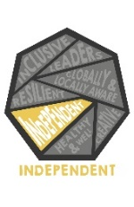 | Students in Lower KS2 will independently assess current designs of products they have been exploring. This will be Christmas stockings and packaging in Years 3/4. Part of the tasks are to identify what works well and what could be improved on current designs and then present ideas to the class or in small groups through discussion. | Upper KS2 develop independence through mechanical and electrical systems, where they are expected to be able to build designs they have made and turn ideas into physical models. Again, students will be assessing prior designs and looking at ways to improve on their own and rationalise their decisions. | Students have an element of independence built into every topic they cover in DT. This is developed and deepened through complexity of topics.  Key skills – Working independently to identify issues and rationalise choice.
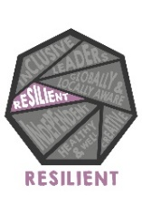 | Lower KS2 topics include some intricate tasks such as sewing and making mechanical systems. These are difficult skills for the students to acquire. Through this challenge, they develop resilience by attempting the same task again until they are happy with the results. Also, by designing something that might not work in reality they are strengthening their resilience to failure. | Resilience is developed further in years 5/6 through mechanical and electrical systems. Students need to be able to justify designs and accept constructive criticism from teachers and peers about what works and what does not. Some of the more intricate skills of model making also develop resilience as there are opportunities to fail and then succeed. | Students’ resilience is developed through trial and error and the acquisition of intricate skills that require patience and repeated practice to achieve the aim.  Key skills - Acquiring new skills through trial and error, building resilience to failure.
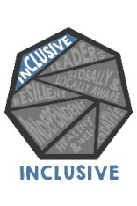 | In years 3/4 students will be expected to present their ideas to the rest of the class and explore other students work, offering critique. This is seen through the healthy food topic or packaging topics where work is shared amongst classes and all students work is explored. | In years 5/6 inclusivity is developed through world foods and textiles. In world foods topic, food is celebrated from around the world and from students’ heritages, giving all students an opportunity to discuss multi-cultural foods and traditions. In textiles, students are invited to explore other students work and offer some points for improvement. This process allows for inclusivity to develop amongst the peer group. | All of the topics in DT offer some form of inclusivity, whether it be group or class discussions, peer group assessment or celebrating the different cultures/backgrounds in the class.  Key skills – Working in groups and sharing ideas to generate inclusivity in the school.

