Colmore PSHE Curriculum
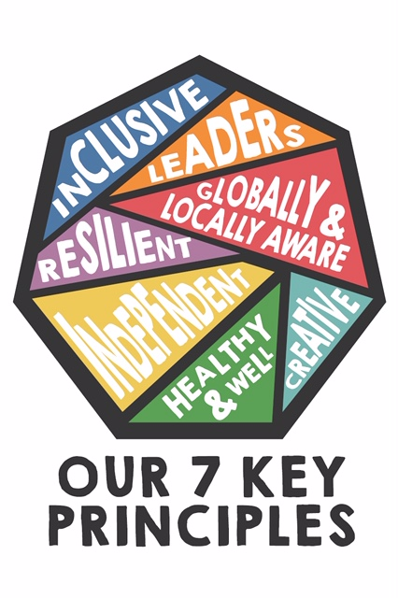
Delivery of the Core Principles
KEY PRINCIPLES | Lower School delivery | Upper School delivery | Progression of skills  Building on knowledge
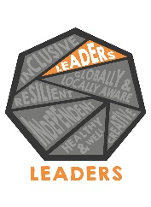 | During Enterprise Week, children use the Skillsbuilder Partnership resources to learn about and practice the following leadership skills: learning how to recognise others’ feelings about something; dividing up tasks to share out in a fair way and managing time; sharing resources to complete a task. They each have a turn to lead their teams in tasks throughout the week. Children also take part in a ‘biscuit democracy’ lesson where they learn about the democratic process; electing leaders and other roles within their group and working to convince the rest of the class to choose their type of biscuit as the ‘best’ in a vote. | During Enterprise Week in upper Key Stage 2, children learn how to manage group discussions to reach shared decisions and to manage disagreements to find shared solutions. They each have a turn to practice these skills during the week when leading their group. Children in Year 5 learn about how democracy works in Britain and take part in a fair vote. In Year 6, when learning about bullying, children consider how they could take a leadership role when being an ‘upstander’ rather than a ‘bystander’ when observing incidences of bullying. | Students develop their ability to lead a group of people effectively, learning how to delegate tasks and find shared solutions to problems.  Key Skills- Leading and managing a group of people effectively.
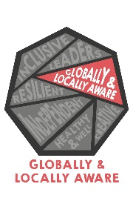 | During the summer term, the O.W.L. focus on ‘Living in the Wider World’ allows children in lower school to explore the issues and impact of flooding in Britain. They consider the role of the emergency services in helping those who have been affected. When learning about Fair Trade, children consider how the choices they make about the products they buy can affect and help people in the wider world. | In upper school, children learn about how people’s lives are impacted by war. They learn the difference between a refugee, asylum seeker and migrant and consider the why people may be forced to flee a country and the impact of this. Children learn about the British Value of individual liberty and how we can support other people’s right to freedom and individual liberty. | Students develop in their understanding of how their actions and choices can affect the lives of other people around the world.  Key Skills – Considering their own place and influence within the wider world.
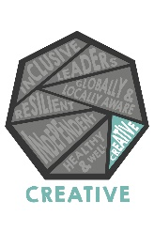 | In lower KS2, children consider strategies for how to solve problems, such as ways to solve disagreements with friends. During Enterprise Week, they generate ideas to meet a brief and think of ways to improve upon their products. | In upper KS2, children think creatively about strategies they could employ to provide support in bullying situations. During Enterprise Week, they generate idea by combining different concepts and use creativity in the context of work, using a range of strategies to solve the problems they come across. | Students think creatively to develop a range of increasingly mature strategies for solving problems.  Key Skills – Developing problem-solving skills.
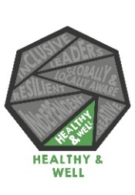 | Children learn how to stay safe in their environment and how to get help if needed. They are visited by the Police force and the Fire Service and learn about the role of emergency workers. Children learn the importance of staying safe online, and how they can report risks or harmful content. They understand how worries and concerns can affect our mental health and that people can experience and recover from mental ill health in the same way as physical health. | Children are taught how to perform basic first aid. They understand how good physical health can support positive mental and emotional health and consider the effect of the media on body image. Children learn about the physical and emotional changes their bodies go through in puberty and how a baby is made. They learn about how their information and data could be used and shared online, how to identify negative influences online and how to stay safe in online relationships. | Students have a clear understanding of the importance of both physical and mental health and think about how to keep themselves and others safe.  Key skills – Identifying risks and strategies for staying safe.
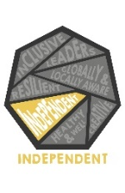 | Children in lower school learn about the importance of taking responsibility for their own learning through having a growth mindset. They learn about situations in which using their own initiative may be required, for example in an emergency situation where they may need to call the police, ambulance or fire service. During Enterprise Week, children use their initiative to come up with ideas and designs for products. | Upper KS2 children learn how to take initiative in emergency situations where they may need to perform first aid. They learn how to independently identify personal opportunities where they can develop resilience. During Enterprise Week, they set goals for themselves, informed by an understanding of what is needed. | Students develop the confidence to take responsibility for their own learning and use initiative to act appropriately in a range of situations.  Key skills – Using initiative to tackle problems.
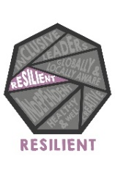 | Lower KS2 children use the book ‘The Girl Who Never Made Mistakes’ and the short film ‘Boy With Chocolate Fingers’ to learn about the importance of a growth mindset. They explore and develop qualities that can help them to build resilience. When learning about the impact of flooding, they consider how affected people demonstrate resilience in their actions. During Enterprise Week, they learn to stay calm and keep trying when things go wrong. | In years 5/6 the children identify opportunities and clear steps they can take to build resilience. They learn about the emotional and physical challenges of puberty and think about how they can display resilience during this time. During Enterprise Week, they learn to stay positive by keeping trying when things are going wrong and encouraging others to keep trying too. | Students learn about the importance of a growth mindset and consider how to build resilience.  Key skills – Demonstrating resilience in the face of challenges.
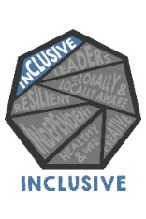 | Children use ‘Giraffes Can’t Dance’ to learn about how everyone is special and unique. They learn that about the importance of respecting people, even if they are very different from us. Children consider practical steps they can take to improve or support respectful relationships. | In upper school, children learn that there are lots of different types of families and that all families are valid. Children learn about what a stereotype is and how stereotypes can be unfair, negative or destructive. They learn that healthy friendships include others and don’t leave people out. During Enterprise Week, children work well with others by understanding and respecting the diversity of their beliefs, cultures and backgrounds. | Students learn about the importance of being respectful towards others and including others.  Key skills – Being respectful and actively involving others.

