## Education with Character at Walthamstow Academy.

At Walthamstow Academy we believe that your character can be shown in the way you present yourself to other people. We also believe that everyone’s character is different because it is made up of different personality traits.

At Walthamstow Academy we expect everyone to show good character, but what does this mean? This will be different for everyone, but really, it is about how you make people feel, how well you treat people and how you are a positive role model for others around you.

Here are some questions to help you think about this:

* Are you kind, polite and respectful?
* Do people feel positive after spending time with you?
* Do people come to you when they need support?
* Do people trust you?
* How do you use your personality to enhance your character? For example are you ambitious for others as well as for yourself?
* Are you a good friend?

.

|  |
| --- |
| Use this box to list the good traits you have and how you show them (there is a list of some good traits later in this section that might help you) |

## The Character Pyramid

Some people struggle to show good character all the time, but we are all learning. Some people are polite because they know they should be, rather than because they just are. Some people are kind when others are watching but when no one is there then perhaps they don’t feel like being kind. Our Character Pyramid describes this journey. Some people do things because they know it is expected of them. But others do things because that is just who they are. Where are you on this Character Pyramid?

|  |
| --- |
| Where do I think I am on the character pyramid and why? |

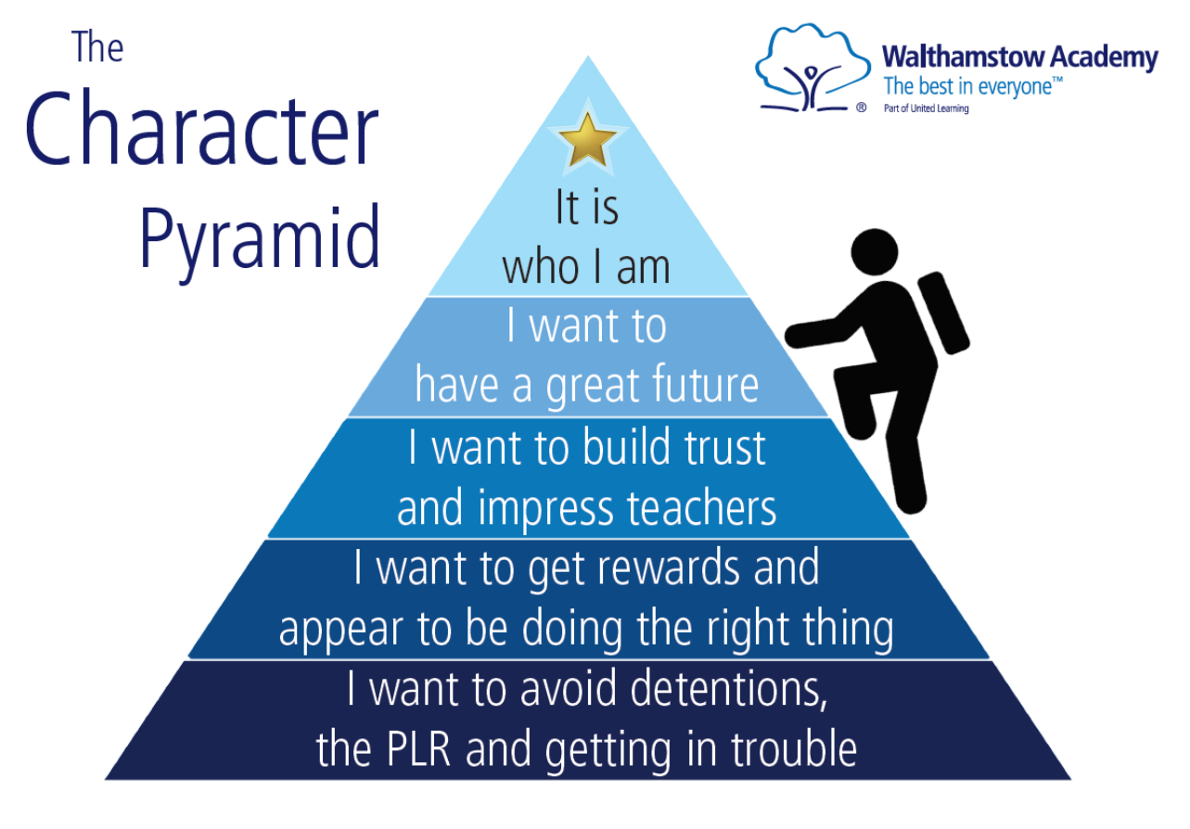

## Ambition

…to achieve the best for ourselves and others.

We show Ambition when we:

* Have high expectations, dream big and believe
* Move out of our comfort zone, broaden our perspectives and extend ourselves
* Be the best we can at all times

Ambition is the value that causes us to make progress. Without ambition, progress is almost impossible.

**Fill in during September induction programme:**

Currently, I have the following thoughts about the career I would like to pursue when I am older:

|  |
| --- |
|  |

## My Chosen Role Model: 1

## Use this space to record your research on a role model you have chosen. Explain how this role model shares your values and is an inspiration to you.

|  |
| --- |
|  |

## My Chosen Role Model: 2

## Use this space to record your research on a role model you have chosen. Explain how this role model shares your values and is an inspiration to you.

|  |
| --- |
|  |

## Determination & Engagement

…to overcome obstacles and reach success.

We show Determination when we:

* Continuously try to improve, learning from feedback and experience
* Show independence yet know when to ask for help
* Embrace failure, overcome barriers and don’t give up

Psychologists sometimes call determination ‘stickability’. The ability to stick at something, even when it’s hard. Determination is considered a key value held by successful people in all walks of life. Those who give up in the moments when it’s tough rarely achieve much that is worthwhile.

We track your determination through your engagement scores, these are reported to you every two weeks in your engagement report. Use the table below to track your average engagement.

|  |  |
| --- | --- |
| Engagement report number | Average engagement score |
|  |  |
|  |  |
|  |  |
|  |  |
|  |  |
|  |  |
|  |  |
|  |  |
|  |  |
|  |  |
|  |  |
|  |  |

|  |  |
| --- | --- |
| My Engagement | |
| Being truly engaged means being immersed in the moment. When we are engaged we have focused our entire attention on what is happening *right now*. Whether that’s in a lesson, working at home or even talking to a friend – being engaged is being truly present and giving all our effort to what we are doing. | |
| 1 – MY ENGAGEMENT IS EXCEPTIONAL | I show exceptional engagement, even when no-one is watching; it is who I am.I am determined, inside and outside of school, to do my best. I research; I complete independent work; I produce excellent and detailed homework to the best of my ability.I am determined to overcome any and all barriers to my own success. |
| 2 – MY ENGAGEMENT IS GOOD | I show engagement when my teachers instruct me to complete work.I am determined, inside and outside of school, to succeed at whatever I do. I complete all classwork and homework to a high standard because I want to have a great future.I am determined to achieve my best and try to overcome some barriers to my success. |
| 3 – I SOMETIMES ENGAGE | I sometimes complete good work for classwork or homework; it depends on the teacher, the subject and how I am feeling that day.I show engagement when I know I will be praised for it because I want to build trust and impress my teachers.I overcome barriers to success when I am offered significant support or reward from my teachers or parents/ carers. |
| 4 – I AM NOT ENGAGED IN MY LEARNING | I complete very little work inside or outside of school. It is sometimes finished and rarely to the best of my ability.I only show engagement when I am worried that I might get in trouble with my teacher for not working or if I think I might get a reward; I want my teachers to think I am doing the right thing.I often give up if I am faced with barriers to my own success, but can be personally persuaded by adults to try and overcome them. |

## Respect

…for ourselves and others in all that we do.

We show Respect when we:

* Value, embrace and celebrate differences
* Demonstrate good manners and are considerate to each other and our environment
* Show empathy and are kind

At Walthamstow Academy, respect is about much more then ‘behaving well’. It is about respecting oneself and respecting those around us in everything we do.

Respect cannot be ‘measured’ directly, but we use respect points to keep track of the recognition we’ve received for the respect we have, or have not, shown.

Respect scores for everyone start at 0. They are changed when you are given P1s, P2s, P3s, warnings, detentions and PLR referrals. This is summarised in the table below:

|  |  |
| --- | --- |
| Sanction or Reward | Change to Respect Points |
| P3 | +10 |
| P2 | +2 |
| P1 | +1 |
| Warning | -1 |
| Detention | -2 |
| PLR referral | -4 |
| Fixed Term Exclusion | -10 |

Every two weeks, your respect points total is calculated. Each year group is then placed in rank order, from the person with the highest number of respect points to the person with the lowest. This rank order is published on a board in the Agora. We do this so that there is complete transparency and so everyone can see clearly how their conduct compares to others. On every New Leaf Monday, respect is reset to ‘0’, there is a New Lead Monday at the start of each half term.

## Respect Points Graph



## Character Reflection at Walthamstow Academy

We use the following pages to reflect on the extent to which we have demonstrated strong values over the last half term. You are asked to make a brief note of these in your diary pages and then draw them together on the pages that follow. Examples that you use should not be limited to your academic studies. You might choose to think about the way you have behaved at home and in the wider community; your work in volunteering to help others, in raising awareness or money for good causes and even in just helping out at home are examples of good character. You are encouraged to consider other values as well our chosen Academy ones: ambition, determination and respect. Examples of other values to consider are shown below, there is a space for you to add any others you consider important:

|  |  |  |  |
| --- | --- | --- | --- |
| **Civic Values** | **Intellectual Values** | **Moral Values** | **Performance Values** |
| Service  Neighbourliness  Citizenship  Community awareness  Volunteering  Social justice | Reflection  Focus  Critical thinking  Reason and judgement  Curiosity  Resourcefulness  Open-mindedness  Wisdom  Creativity | Courage  Compassion  Gratitude  Justice  Honesty  Humility  Modesty  Self-discipline  Tolerance  Integrity  Friendliness  **Respect**  Trust | Resilience  Perseverance  **Determination**  Leadership  Teamwork  Confidence  Motivation  **Ambition**  Problem-solving  Communication |

## Your Character Reflection Half Term 1

Last year, I demonstrated good character in relation to my school work.

I did this by:

|  |
| --- |
|  |

Last year, I demonstrated good character outside of my school work.

I did this by:

|  |
| --- |
|  |

This half term, I intend to show demonstrate good character as I complete my school work.

I will do this by:

|  |
| --- |
|  |

This half term, I intend to demonstrate good character outside of my school work.

I will do this by:

|  |
| --- |
|  |

## Your Character Reflection Half Term 2

Last half term, I demonstrated good character in relation to my school work.

I did this by:

|  |
| --- |
|  |

Last half term, I demonstrated good character outside of my school work.

I did this by:

|  |
| --- |
|  |

This half term, I intend to show demonstrate good character as I complete my school work.

I will do this by

|  |
| --- |
|  |

This half term, I intend to demonstrate good character outside of my school work.

I will do this by:

|  |
| --- |
|  |

## Your Character Reflection Half Term 3

Last half term, I demonstrated good character in relation to my school work.

I did this by:

|  |
| --- |
|  |

Last half term, I demonstrated good character outside of my school work.

I did this by:

|  |
| --- |
|  |

This half term, I intend to show demonstrate good character as I complete my school work.

I will do this by:

|  |
| --- |
|  |

This half term, I intend to demonstrate good character outside of my school work.

I will do this by:

|  |
| --- |
|  |

## Your Character Reflection Half Term 4

Last half term, I demonstrated good character in relation to my school work.

I did this by:

|  |
| --- |
|  |

Last half term, I demonstrated good character outside of my school work.

I did this by:

|  |
| --- |
|  |

This half term, I intend to show demonstrate good character as I complete my school work.

I will do this by

|  |
| --- |
|  |

This half term, I intend to demonstrate good character outside of my school work.

I will do this by:

|  |
| --- |
|  |

## Your Character Reflection Half Term 5

Last half term, I demonstrated good character in relation to my school work.

I did this by:

|  |
| --- |
|  |

Last half term, I demonstrated good character outside of my school work.

I did this by:

|  |
| --- |
|  |

This half term, I intend to show demonstrate good character as I complete my school work.

I will do this by

|  |
| --- |
|  |

This half term, I intend to demonstrate good character outside of my school work.

I will do this by:

|  |
| --- |
|  |

## Your Character Reflection Half Term 6

Last half term, I demonstrated good character in relation to my school work.

I did this by:

|  |
| --- |
|  |

Last half term, I demonstrated good character outside of my school work.

I did this by:

|  |
| --- |
|  |

This half term, I intend to show demonstrate good character as I complete my school work.

I will do this by

|  |
| --- |
|  |

This half term, I intend to demonstrate good character outside of my school work.

I will do this by:

|  |
| --- |
|  |