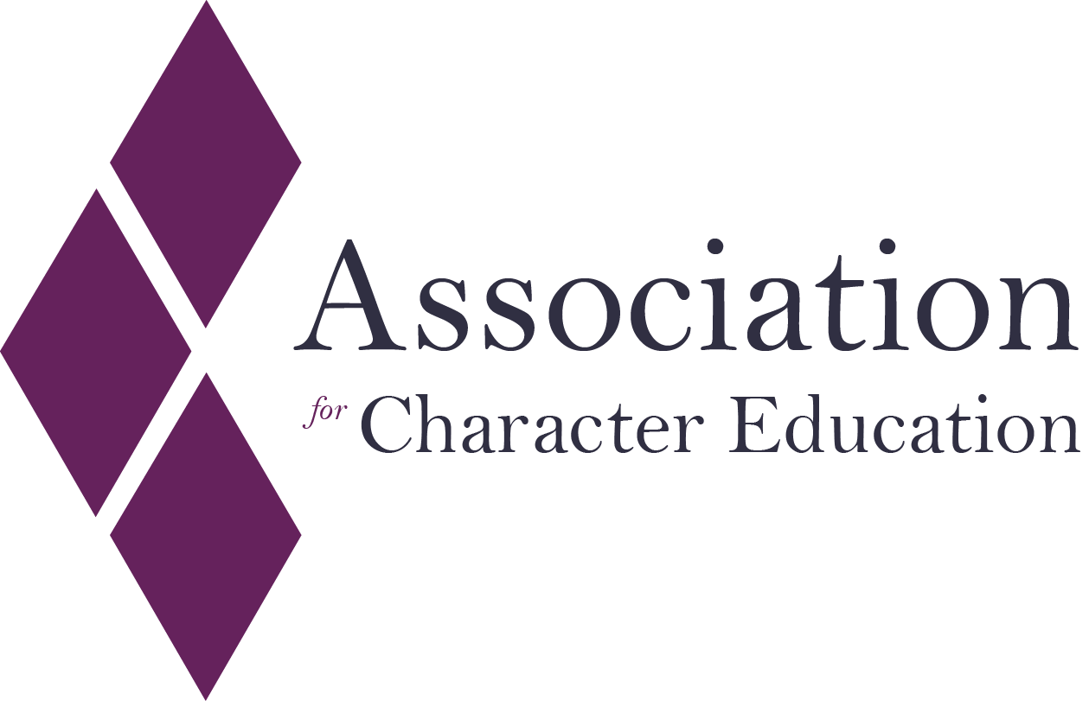

SCHOOLS OF CHARACTER KITEMARK

Please read the information pack before completing this form. For support and submission please contact Tom Haigh on 07771971703 or Email: [tom.haigh@character-education.org.uk](mailto:tom.haigh@character-education.org.uk)

**APPLICATION FORM**

School Name

School Address

Type of School (delete as appropriate)

Primary / Secondary / College

Contact Name

Head-teacher name if different from above

Contact Phone Number

Contact Email  
Are you applying for the Kitemark or Kitemark Plus?

Please submit your application to [tom.haigh@character-education.org.uk](mailto:tom.haigh@character-education.org.uk)

**Part A:** Please describe in no more than 500 words how you believe your school or college meets or exceeds the Schools of Character Kitemark or Kitemark Plus Framework

**Part B:** Provide up to 6 pieces of evidence, as bullet points, that demonstrate how your school / college meets the 4 criteria at either the Kitemark or Kitemark Plus level. Refer to the detailed criteria descriptions in the Kitemark information pack.

B: Character Education is explicit in the formal and non-formal curriculum



A: Character education is explicit in the school /college ethos, culture and vision



D: Character education is undertaken in partnership with local School Community



C: Leaders in schools and colleges adopt a conscious, planned and reflective approach to character education